0

['2003-08-01']

['2007-08-02']

250

-5.0

-0.036900871459695006

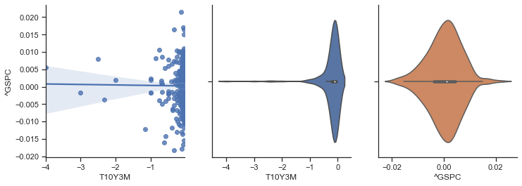

0.06794854253076321

338

-0.036900871459695006

0.0

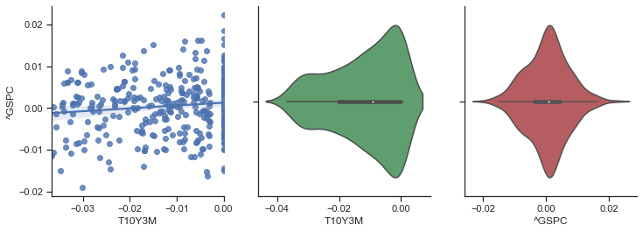

0.15171400932564671

165

0.0

0.024629110117016628

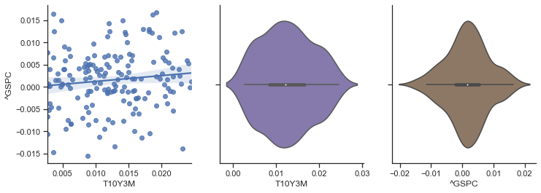

0.2567305792339418

252

0.024629110117016628

5.0

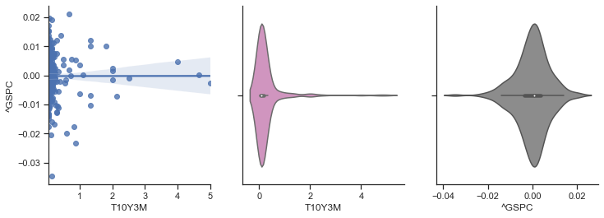

-0.05191695623481152

1

['2004-08-03']

['2008-08-01']

251

-13.0

-0.054337843286591136

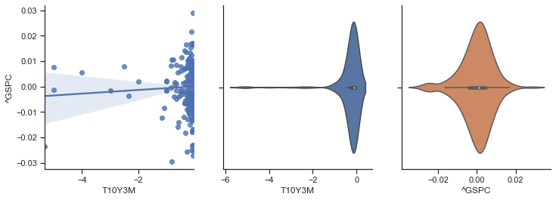

-0.03429643543267524

317

-0.054337843286591136

0.0

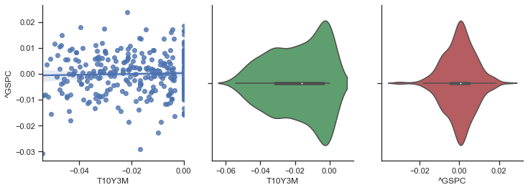

0.0014721709202856204

187

0.0

0.04662868737318565

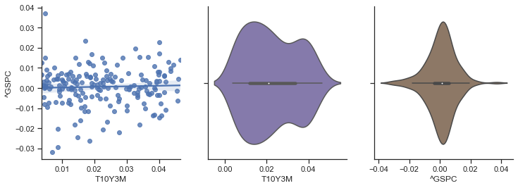

0.11280402946673385

252

0.04662868737318565

5.0

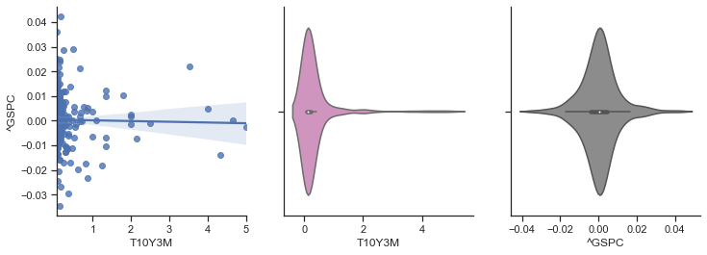

0.08859030664342171

2

['2005-08-02']

['2009-08-03']

251

-13.0

-0.057474436439693216

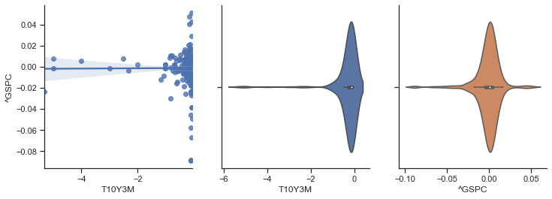

-0.28988449608898237

282

-0.057474436439693216

0.0

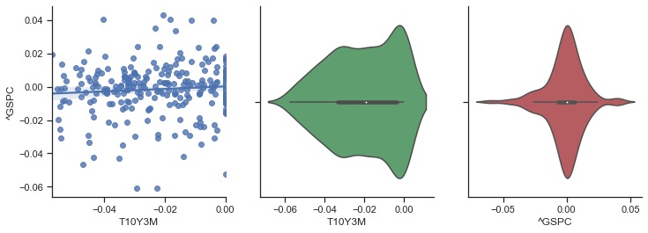

-0.3682859755735399

222

0.0

0.052807017543859636

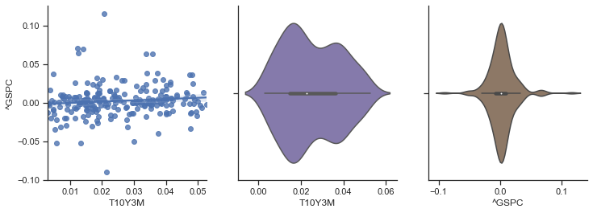

0.5004275678807286

252

0.052807017543859636

5.0

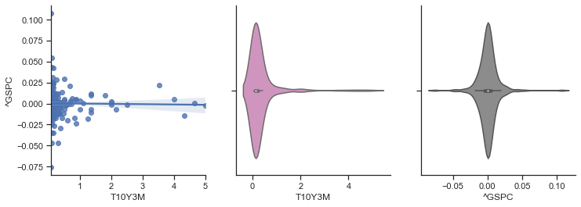

0.0846654494804665

3

['2006-08-02']

['2010-08-03']

251

-13.0

-0.027875586854460205

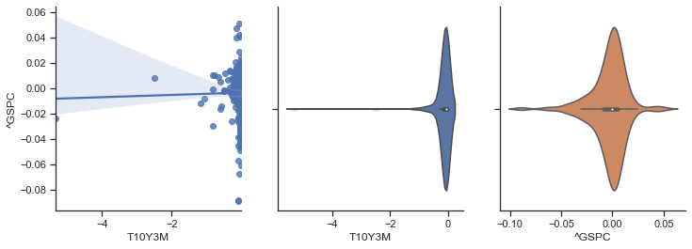

-0.893751658516994

261

-0.027875586854460205

0.0

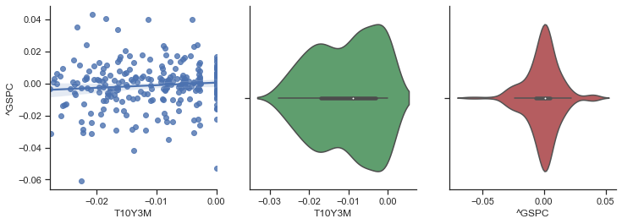

-0.287358451967638

243

0.0

0.03286604361370715

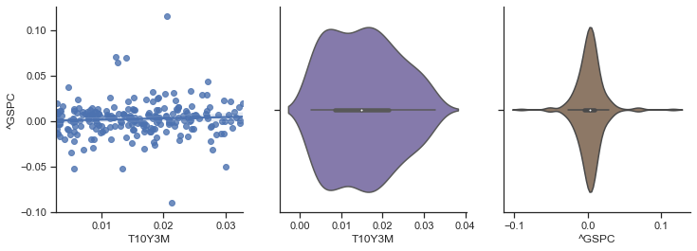

0.5484420392044099

252

0.03286604361370715

4.666666666666667

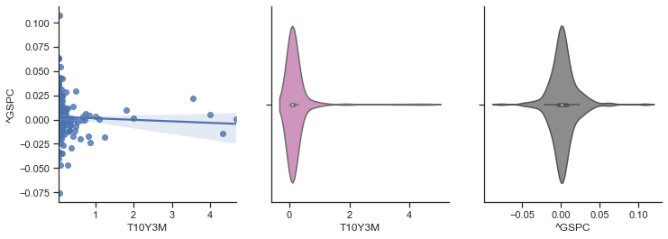

0.6539504693222244

4

['2007-08-03']

['2011-08-02']

251

-13.0

-0.01839505963675797

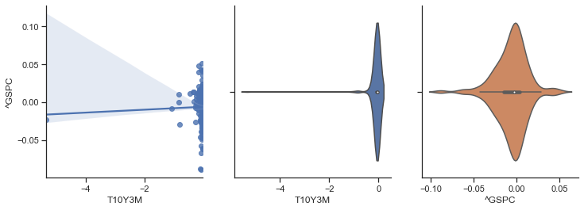

-1.534186402060472

260

-0.01839505963675797

0.0

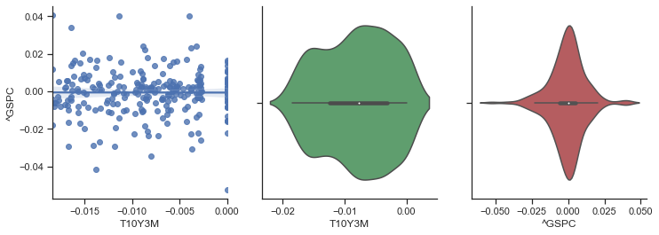

-0.17017771503278367

244

0.0

0.01942098506857648

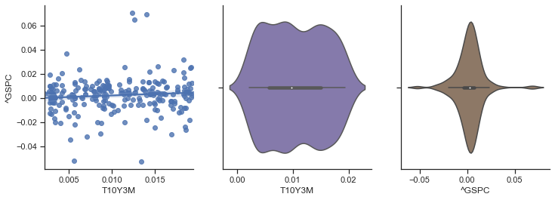

0.5516664437107605

252

0.01942098506857648

4.333333333333333

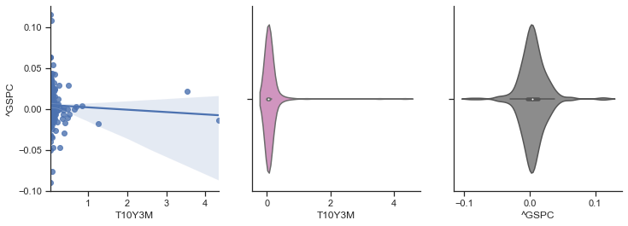

1.1434388345427016

5

['2008-08-04']

['2012-08-01']

251

-0.17266187050359716

-0.01781811397196012

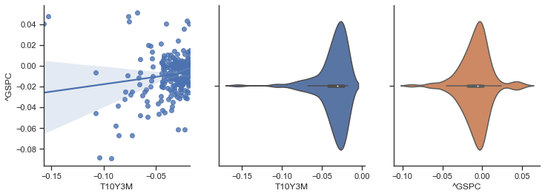

-2.17827147111302

285

-0.01781811397196012

0.0

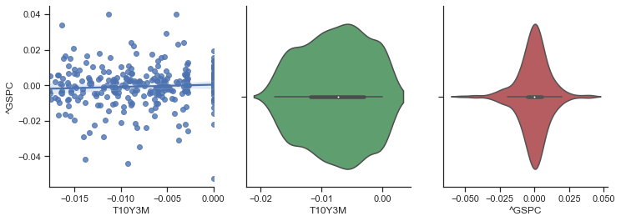

-0.19022634600865573

219

0.0

0.016434842093261848

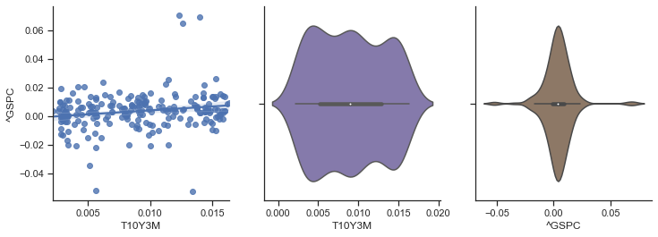

0.7627447753002475

252

0.016434842093261848

0.2803030303030303

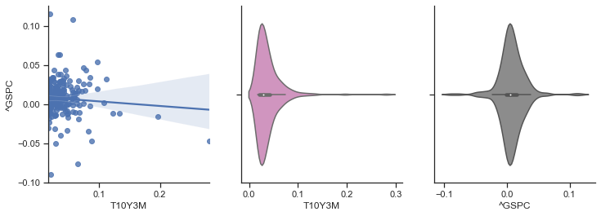

1.8290016133329785

6

['2009-08-04']

['2013-08-05']

251

-0.08560311284046684

-0.015682187464097525

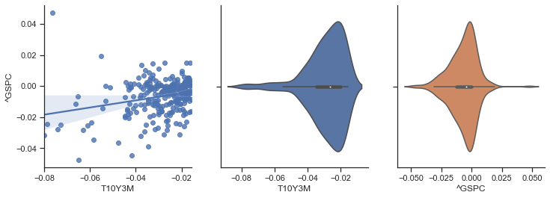

-1.7161071041027869

302

-0.015682187464097525

0.0

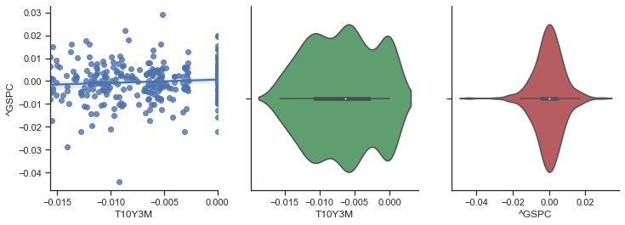

-0.09347200156931512

202

0.0

0.014771145715711143

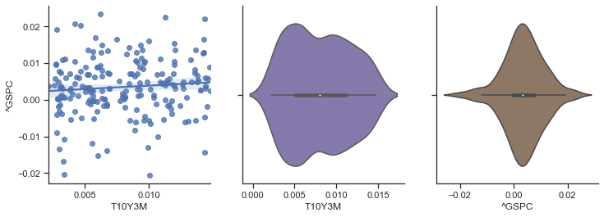

0.7049644337329165

252

0.014771145715711143

0.09701492537313428

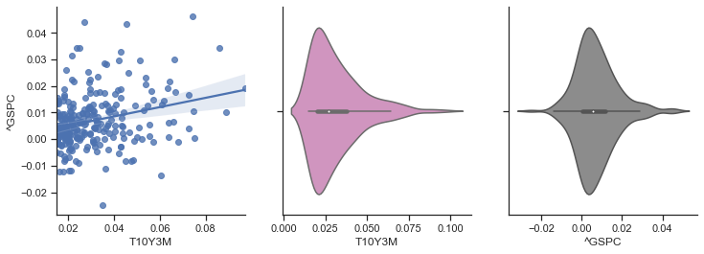

1.7643613722839029

7

['2010-08-04']

['2014-08-05']

252

-0.08560311284046684

-0.015060240963855387

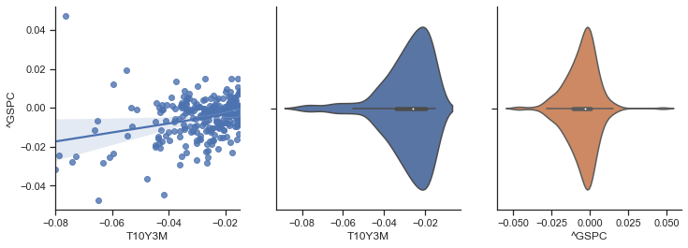

-1.3813256318841962

301

-0.015060240963855387

0.0

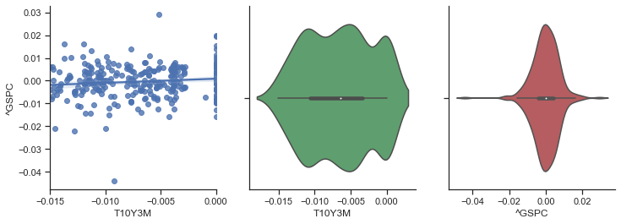

-0.0944949424184881

202

0.0

0.014972863262239622

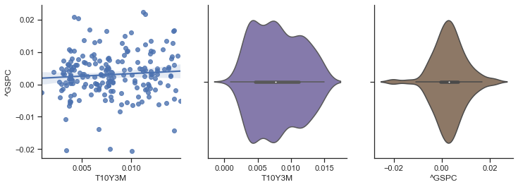

0.6149482688987731

252

0.014972863262239622

0.09701492537313428

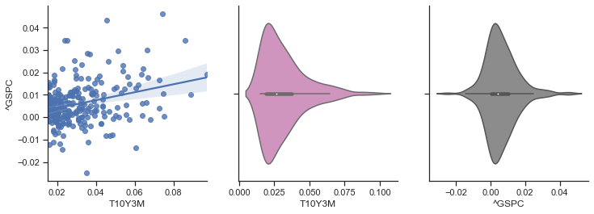

1.5150712540495537

8

['2011-08-03']

['2015-08-05']

251

-0.08560311284046684

-0.01491181485311796

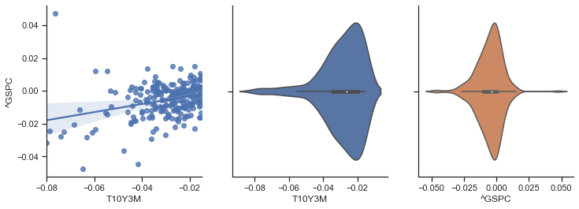

-1.3427637702886714

310

-0.01491181485311796

0.0

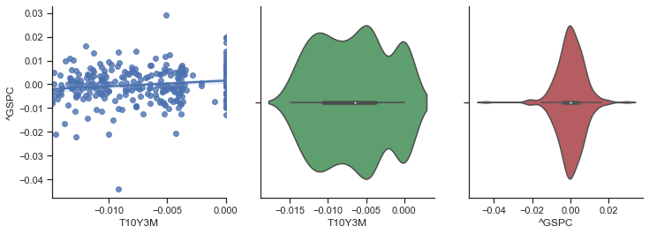

-0.013109699616750459

194

0.0

0.01441455531227187

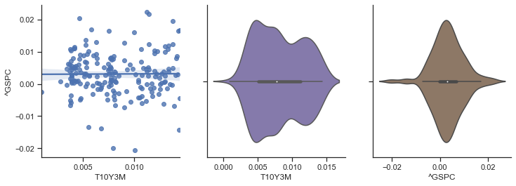

0.6060391404357363

252

0.01441455531227187

0.09701492537313428

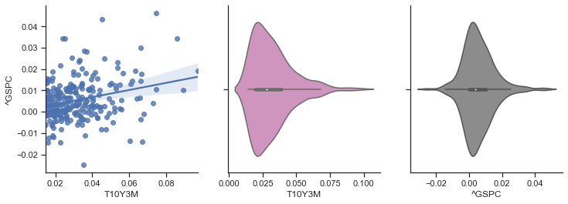

1.3787285268350493

9

['2012-08-02']

['2016-08-04']

251

-0.09090909090909083

-0.014247736499685693

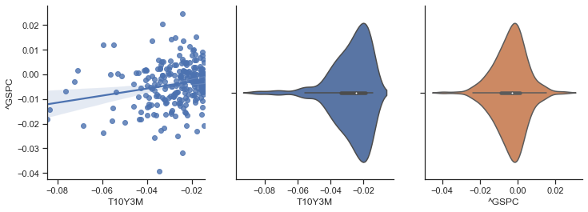

-1.0043257529905476

311

-0.014247736499685693

0.0

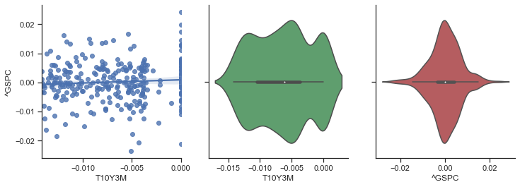

0.06275534514289516

193

0.0

0.014096949186283791

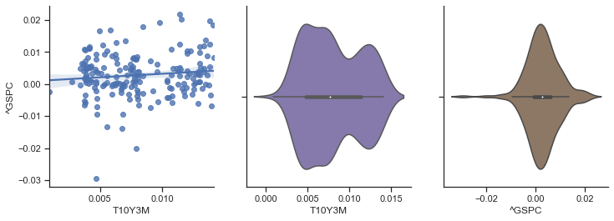

0.5302339797211707

252

0.014096949186283791

0.10714285714285698

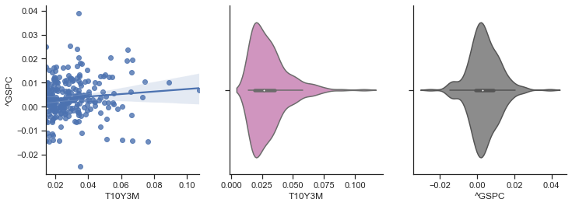

0.9348398716720313

10

['2013-08-06']

['2017-08-04']

252

-0.09090909090909083

-0.01526717557251911

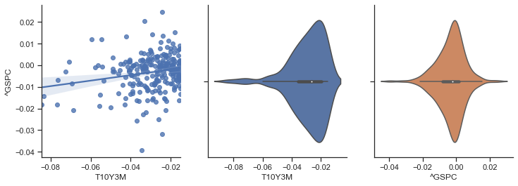

-0.814410044462648

313

-0.01526717557251911

0.0

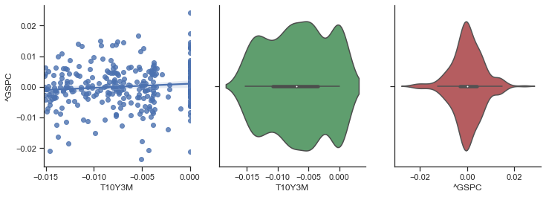

0.037145104368672244

190

0.0

0.014234935680433325

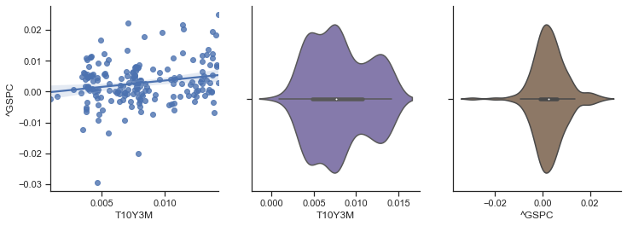

0.5292542170936557

252

0.014234935680433325

0.11724137931034484

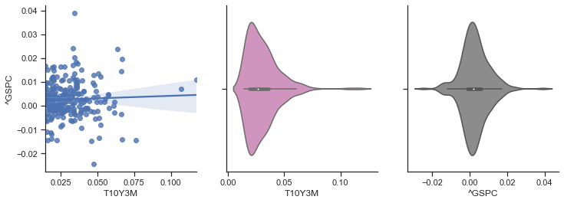

0.686593976373039

11

['2014-08-06']

['2018-08-06']

252

-0.18446601941747576

-0.019108280254777066

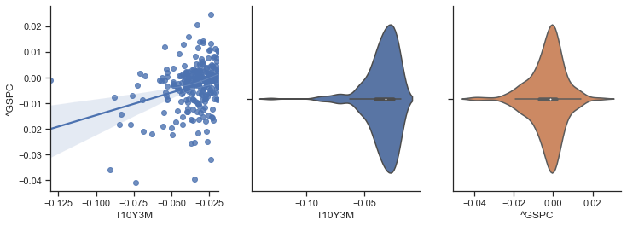

-0.7947355172580783

315

-0.019108280254777066

0.0

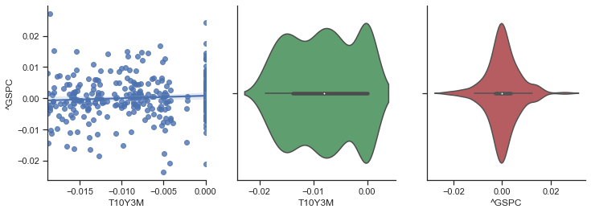

0.05314673372752532

188

0.0

0.018038400391341414

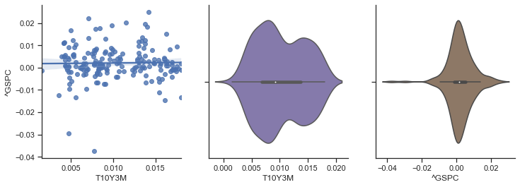

0.3955491167951598

252

0.018038400391341414

0.11724137931034484

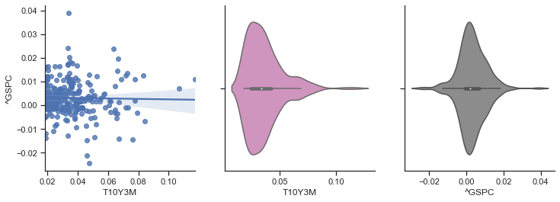

0.7855950121747949

12

['2015-08-06']

['2019-08-07']

251

-7.0

-0.025466966447595996

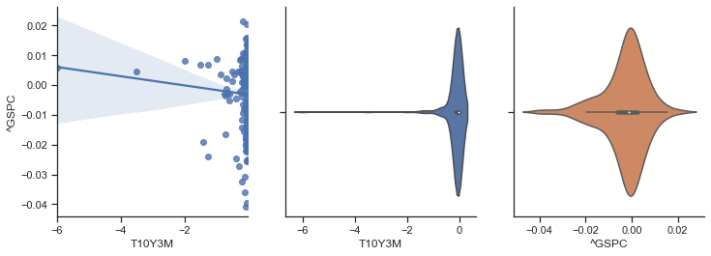

-0.7380023088657374

328

-0.025466966447595996

0.0

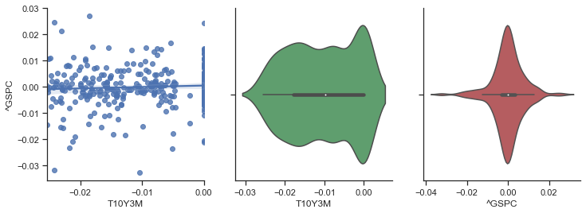

-0.030182797983357434

176

0.0

0.020725388601036343

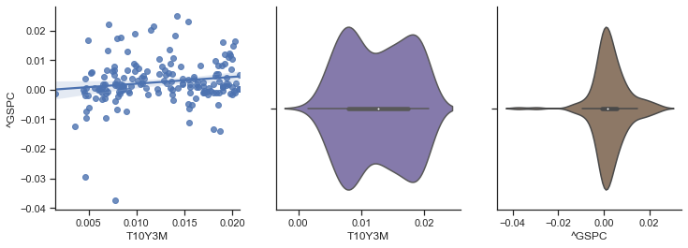

0.4633876979842032

251

0.020725388601036343

5.0

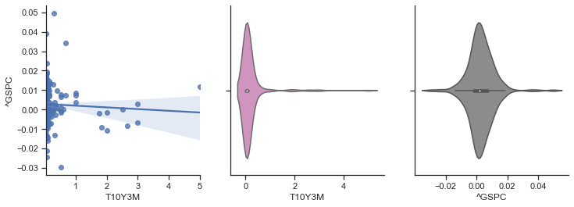

0.6777883560068464

13

['2016-08-05']

['2020-08-06']

251

-9.0

-0.03555625790139055

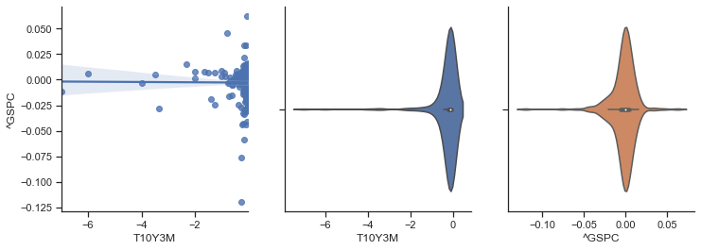

-0.7067617736187843

335

-0.03555625790139055

0.0

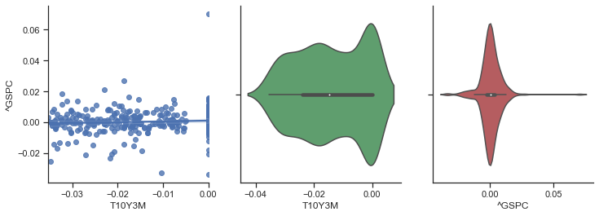

0.13866558535854323

169

0.0

0.03125

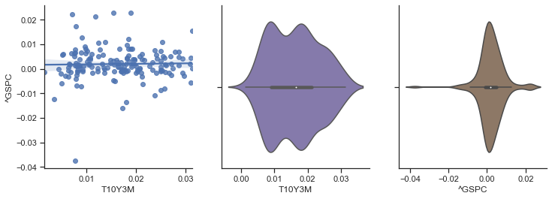

0.3391088861440764

251

0.03125

5.0

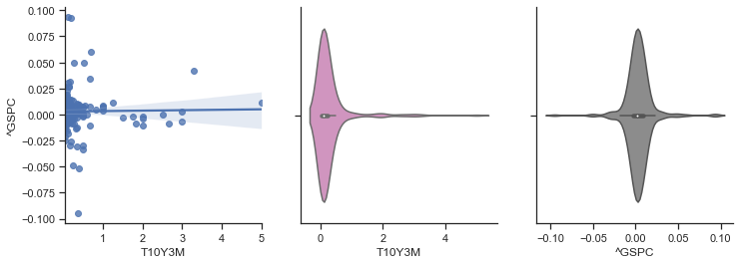

0.7407421398733672